|  |  |
| --- | --- |
| Year 9 Science:  Body Co-ordination Test  ANSWER KEY | |
| Multiple Choice:  Short Answer:  Extended Response:  Mark: | ____ / 10  ____ / 44  ____ / 6  ____ / 60  ____ % |

**Multiple Choice Answers**

|  |  |  |  |  |  |  |  |  |  |  |
| --- | --- | --- | --- | --- | --- | --- | --- | --- | --- | --- |
| **Question** | **Response** | | | |  | **Question** | **Response** | | | |
| 1 | A | B | C | D |  | 6 | A | B | C | D |
| 2 | A | B | C | D |  | 7 | A | B | C | D |
| 3 | A | B | C | D |  | 8 | A | B | C | D |
| 4 | A | B | C | D |  | 9 | A | B | C | D |
| 5 | A | B | C | D |  | 10 | A | B | C | D |

**Short Answer**

Write your answers in the spaces provided.

**Question 1: Responding to Stimuli**

Match each of the sense organs to the receptors they contain and name the stimulus each organ detects. Some may be used more than once. (5)

*Mechanoreceptors Photoreceptors Chemoreceptors Thermoreceptors*

|  |  |  |
| --- | --- | --- |
| **Sense Organ** | **Receptor** | **Stimulus** |
| Eye | Photoreceptors | Light or movement |
| Ear | Mechanoreceptors | Sound or vibrations in air |
| Nose | Chemoreceptors | Smells or chemicals in air |
| Tongue | Chemoreceptors | Taste or chemicals in food |
| Skin | Mechanoreceptors or Thermoreceptors | Touch or pain / temperature |

**Question 2: The Structure of the Brain**

1. Label the parts of the brain using the words listed below. (3)

Cerebellum Frontal Brain stem Parietal Occipital Temporal

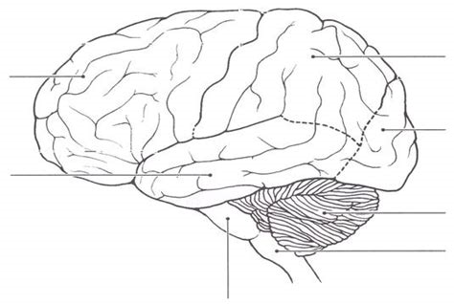 ½ mark each

Frontal

Parietal

Occipital

Temporal

Cerebellum

Brain stem

Spinal cord

1. Match the lobes of the brain to their function. 1 mark each (4)

|  |  |
| --- | --- |
| **Lobe** | **Function** |
| Temporal | Recognising sounds and smells |
| Frontal | Reasoning, emotions and problem solving |
| Occipital | Perception of vision |
| Parietal | Perception of taste, pain, temperature and touch |

**Question 3: Peripheral Nervous System**

The peripheral nervous system is divided into the somatic nervous system and the autonomic nervous system. For each situation below, state which system is in control and give a reason why? (4)

1. Sally’s breathing rate increases when she goes for a run.

This is controlled by the autonomic nervous system (1) because it is an involuntary action / she doesn’t have voluntary control of the action (1)

1. Harold covers his eyes with his hands when his mum turns on the bedroom light.

This is controlled by the somatic nervous system (1) because it is a voluntary action / she has control over the action (1)

**Question 4: Neurons**

1. Label the diagrams of neurons with their type. (1)

1 mark if all correct, ½ mark if 2 correct, no mark if 1 or none correct

1. 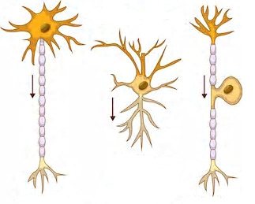Explain the difference in the **function** of sensory and motor neurons. (2)

A sensory neuron carries messages from sense  
 organs to the CNS / brain and spinal cord (1)

Sensory neuron

Motor neuron

Interneuron

A motor neuron carries messages from the   
CNS / brain and spinal cord to effectors / muscles   
and organs (1)

**Question 5: Stimulus – Response Model and Reflexes**

1. What is a reflex response? (1)

An involuntary, almost instantaneous response

1. How is a reflex different to a normal stimulus – response? (2)

A normal stimulus-response is processed by the brain (½) and is slower (½)

A reflex action is processed by the spinal cord (½) making it faster (½)

1. Use the stimulus response model to show how the body responds in each situation. (6)

**Stimulus 🡪 Receptor 🡪 Control centre 🡪 Effector 🡪 Response**

1. You touch a hot object and pull your hand away quickly.

Heat (½) 🡪 Temperature receptors (½) in skin (½) 🡪 Spinal cord (½) 🡪 Arm muscles (½) 🡪 Hand moves (½)

1. Someone calls your name and you look in their direction.

Sound (½) 🡪 Mechanoreceptors (½) in ears (½) 🡪 Brain (½) 🡪 Neck muscles (½) 🡪 Head turns (½)

**Question 6: Homeostasis and Regulating Blood Glucose**

1. What is homeostasis? (1)

Maintaining or regulating the internal conditions of the body

1. Other than blood glucose, name two things homeostasis controls. (1)

Any two of temperature, water, salt, oxygen or wastes

1. Blood glucose is controlled using negative feedback. Complete the negative feedback for the body responding to the change in blood glucose after eating a large meal. 1 mark each (4)

Blood glucose increases

Pancreas secretes insulin

Liver stores excess glucose

Blood glucose decreases

Glucose change Role of pancreas Role of liver Feedback

**Question 7: Pathogens and Disease**

Chicken pox is a disease caused by a viral pathogen called varicella.

1. Could this disease be treated with antibiotics? Explain your choice. (2)

This disease is caused by a virus which cannot be treated with antibiotics (1). Viruses have a protective layer so they are unaffected by antibiotics (1)

1. Could this disease be prevented with a vaccine? Explain your choice. (2)

This disease could be prevented with a vaccine because it is a virus (1). The vaccine helps the body develop immunity to the pathogen (1)

**Question 8: The Immune System**

The role of the immune system is to prevent pathogens from entering the body and attacking them if they do enter. The immune system has three lines of defence against pathogens.

Briefly explain each line of defence, using examples. (6)

First line of defence:

Using physical and chemical barriers to stop pathogens getting into the body (1)

Examples could include: (1)

* Skin is thick and waterproof, produces oil/sweat to kill bacteria
* Mucous membranes in body openings to trap pathogens

Second line of defence:

Destroy pathogen using a non-specific immune response (1)

Examples could include: (any 2 for 1 mark)

* Blood clotting to prevent further infection
* Inflammation brings more white blood cells
* Fever damages pathogens at high temperatures

Third line of defence:

Develop immunity to the pathogen (1)

Examples could include: (any 2 for 1 mark)

* B cells produce antibodies which fit onto pathogens
* T cells seek and destroy the pathogen
* Memory cells are produced in case the pathogen re-enters the body

**Academic Extension: Extended Response (6 marks)**

1 mark for stating what causes the disease (pathogen type and name)

1 mark for naming 3-4 symptoms of disease

½ mark for naming 1-2 symptoms of disease

1 mark for explaining how disease is transmitted

1 mark for explaining treatments

1 mark for explaining how the disease can be prevented

1 mark for other information

For a disease of your choice, explain what causes the disease and the symptoms a person with the disease shows. Describe how the disease is spread from one person to another and how it can be treated. Briefly explain the way the disease can be prevented and any other important information about the disease.

__________________________________________________________________________________________________________________________________________________________________________________________________________________________________________________________________________________________________________________________________________________________________________________________________________________________________________________________________________________________________________________________________________________________________________________________________________________________________________________________________________________________________________________________________________________________________________________________________________________________________________________________________________________________________________________________________________________________________________________________________________________________________________________________________________________________________________________________________________________________________________________________________________________________________________________________________________________________

**End of Test**

**Multiple Choice Questions**

**Do not write on this sheet. Circle your choice on the first page of your test paper.**

1. Identify the part of the neuron labelled 1 in the diagram.
   1. 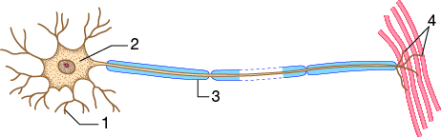Axon
   2. Dendrite
   3. Synaptic terminal
   4. Cell body
2. Name the two parts of the peripheral nervous system.
   1. Brain and spinal cord
   2. Somatic and autonomic
   3. Central and somatic
   4. Autonomic and central
3. Which activity would be difficult after sustaining damage to the cerebellum?
   1. Speech
   2. Walking
   3. Breathing
   4. Intellectual thought
4. Which of the following glands does not belong to the endocrine system?
   1. Pituitary
   2. Thyroid
   3. Salivary
   4. Adrenal
5. If you were to eat four sugary doughnuts and drink a large Coke, which hormone would you expect to secrete at higher levels?
   1. Insulin
   2. Adrenaline
   3. Glucagon
   4. Oestrogen
6. Describe the relationship between the pituitary gland and the hypothalamus.
   1. The pituitary is called the master gland. The hypothalamus responds to messages from the pituitary gland
   2. The hypothalamus secretes hormones that act on the pituitary gland
   3. The hypothalamus is part of the brain and the pituitary is located in front of the trachea in the neck
   4. The hypothalamus checks the conditions within the organs and the pituitary checks the activity of the brain
7. 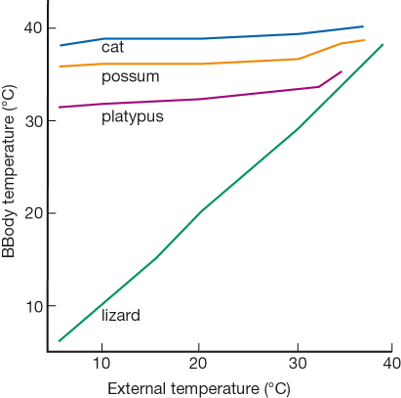Identify the organism whose body temperature is least likely to be controlled by homeostasis.
   1. Cat
   2. Possum
   3. Platypus
   4. Lizard
8. Identify the correct statement about the diagram
   1. (1) is a target cell and it produces the hormone represented by (2)
   2. (4) is a target cell for the hormone represented by (2)
   3. 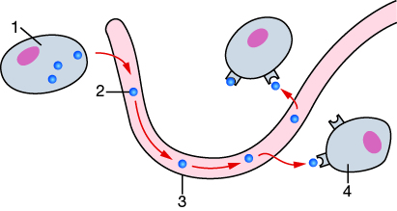(1) is a cell in an endocrine gland and (3) is the duct that carries the hormone (2) to the target cells (4)
   4. (3) is a blood vessel carrying the hormone (2) from the target cell (1) to the other body cells (4)
9. What is the definition of a pathogen?
   1. A substance that kills bacteria or prevents the growth of bacteria
   2. The organism that a parasite lives in
   3. A white blood cell that makes antibodies
   4. An organism that causes disease
10. Four paper discs were soaked in antibiotics. The discs were place on an agar plate with a large number of bacterial colonies. The aim of the experiment was to test the effectiveness of the antibiotics. The diagram shows the results after three days.

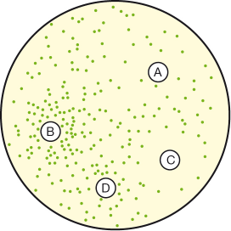

The antibiotics in order from most effective to least effective is:

* 1. D, A, C, B
  2. C, A, D, B
  3. B, D, A, C
  4. B, C, A, D